AI5707 — Pattern Recognition and Machine Learning
Assignment 4: Multivariate Gaussian Density Functions, Covariance Matrices and Constant Density Curves
Solved implementation and experimental report

1. Objective
The objective is to generate two-dimensional Gaussian data under isotropic, diagonal and full covariance matrices, estimate covariance matrices and eigenpairs from samples, visualize constant Mahalanobis-distance curves, and study decision boundaries between two Gaussian classes.

2. Parameter settings
The Assignment 4 sheet refers to μ1 and μ2 from Assignment 1 but does not state their numerical values. The supplied implementation therefore uses μ1 = −2 and μ2 = 2, variance 1 for the base one-dimensional Gaussian variables, N = 2000, and random seed 42. These values are explicitly configurable in assignment4.py.
Experiment | Covariance
Q1 Isotropic | [[1. 0.]  [0. 1.]]
Q2 Diagonal | [[4. 0.]  [0. 1.]]
Q3 Full | [[4. 1.2]  [1.2 1.5]]

3. Theory
For x ∈ R² and x ~ N(μ, Σ),
p(x) = [1 / ((2π)√|Σ|)] exp{−½ (x−μ)ᵀΣ⁻¹(x−μ)}
A constant-density contour corresponds to a constant value c of the quadratic form (x−μ)ᵀΣ⁻¹(x−μ)=c. If Σ=QΛQᵀ, the contour axes are aligned with the columns of Q, and the semi-axis length in eigen-direction i is √(c λi).
For two Gaussian classes with equal priors, the discriminant can be written as g(x)=log p(x|ω1)−log p(x|ω2). When Σ1=Σ2, the xᵀΣ⁻¹x terms cancel, so the decision surface is linear. When Σ1≠Σ2, a quadratic term remains, producing a generally quadratic decision boundary.

4. Q1 — Isotropic covariance
Two independent Gaussian variables were generated and combined as x=[x1,x2]ᵀ. The target covariance is I. The sample covariance should therefore approach the identity matrix as N increases.
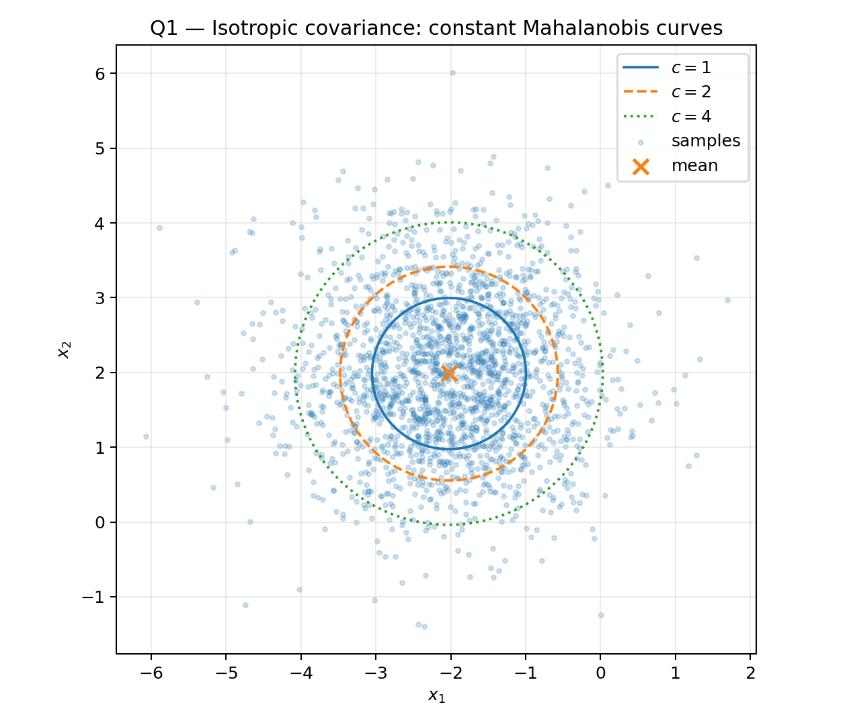
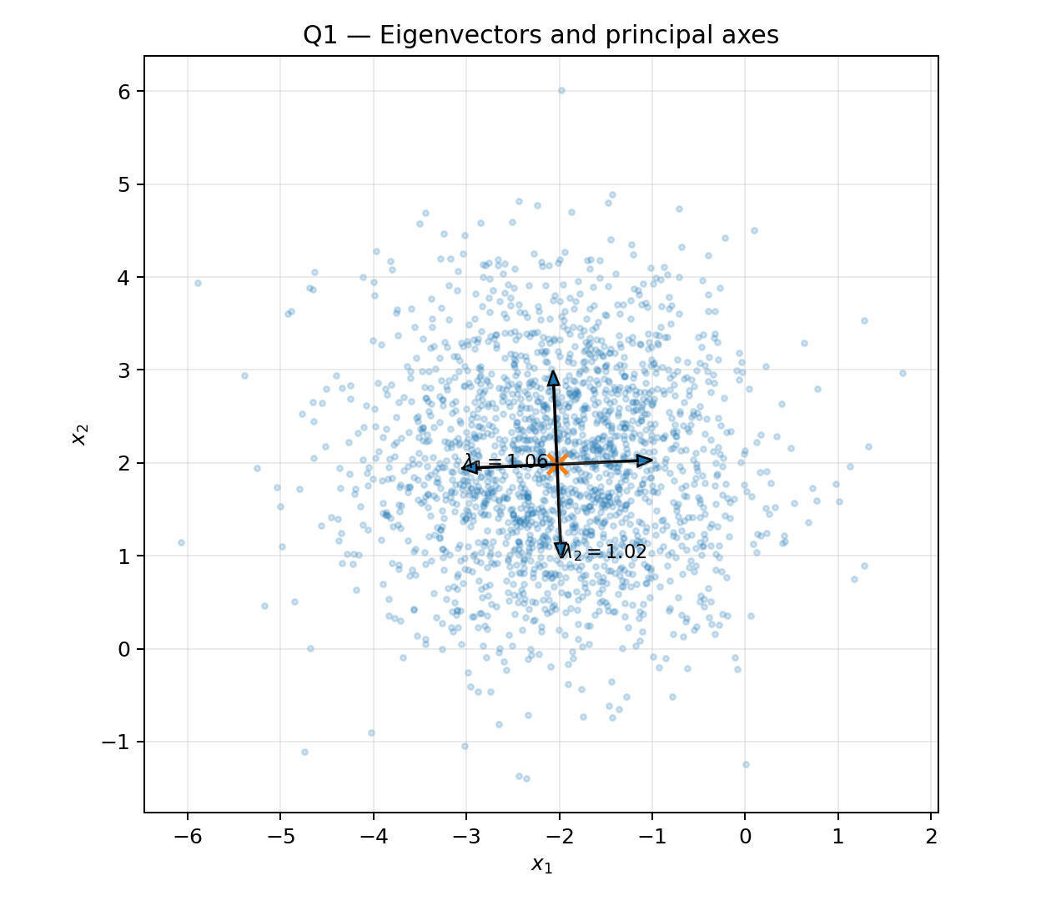
Estimated mean = [-2.0241 1.985 ]. Estimated covariance = [[1.0561 0.0014]
[0.0014 1.0225]]. Eigenvalues = [1.0562 1.0225]. The two eigenvalues are close to one, so the principal axes have approximately equal length and the constant-density curves are close to circles.

5. Q2 — Diagonal covariance
The base data were transformed using Y=μ+Σ^{1/2}(X−μ), with Σ=diag(4,1). Because the off-diagonal covariance is zero, the ellipse axes remain aligned with the coordinate axes. The larger eigenvalue corresponds to the longer axis.
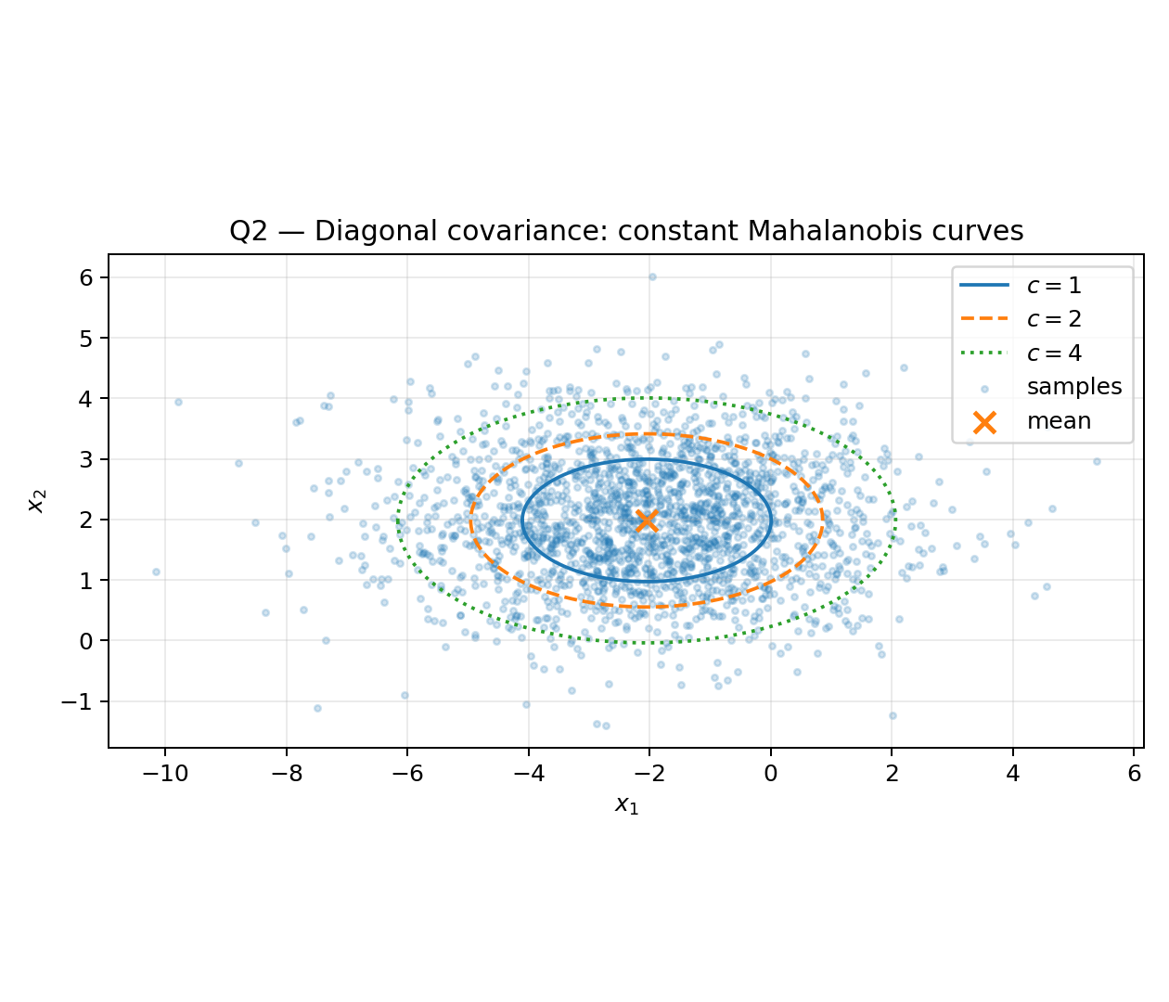
Estimated covariance = [[4.2245e+00 2.8965e-03]
[2.8965e-03 1.0225e+00]]. Eigenvalues = [4.2245 1.0225]. The eigenvectors are approximately the coordinate directions.

6. Q3 — Full covariance
The full covariance matrix used was [[4,1.2],[1.2,1.5]]. The nonzero off-diagonal terms create correlation between x1 and x2. Consequently, the principal axes rotate away from the coordinate axes.
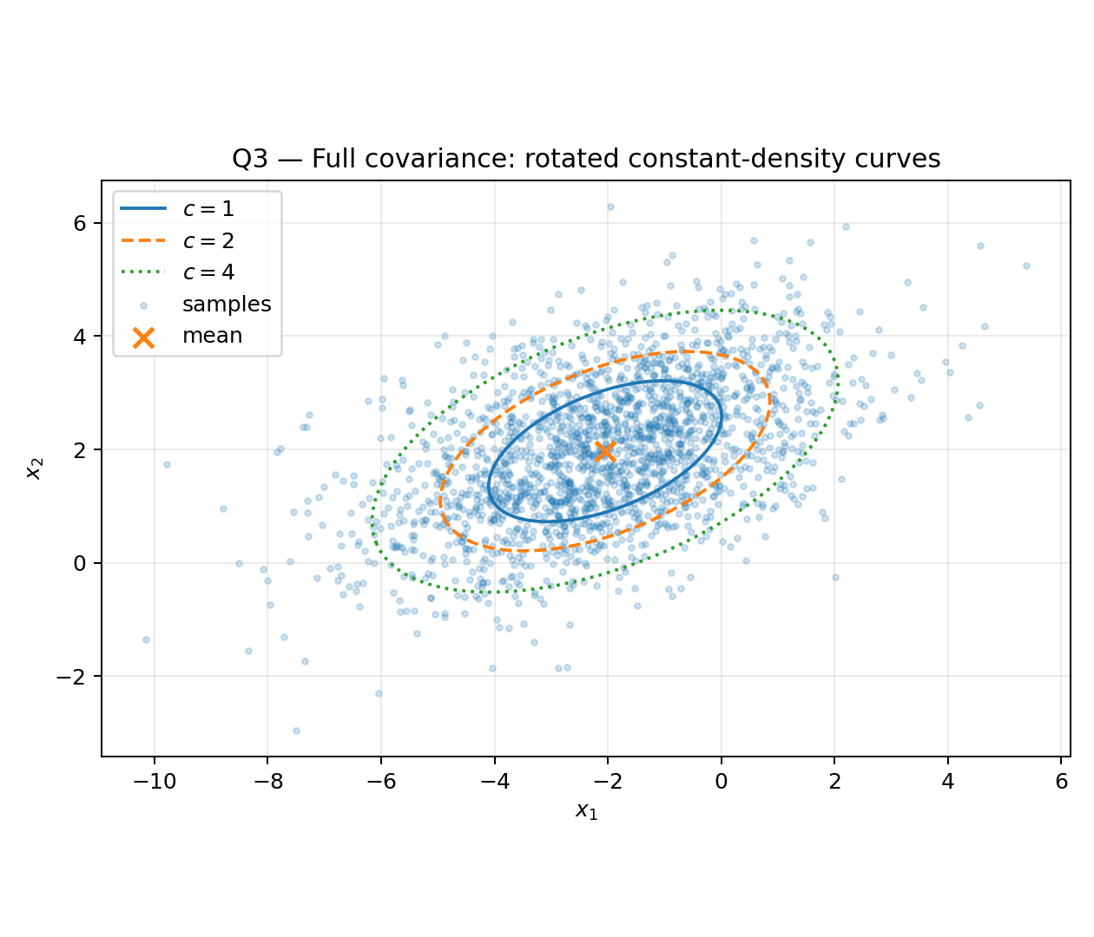
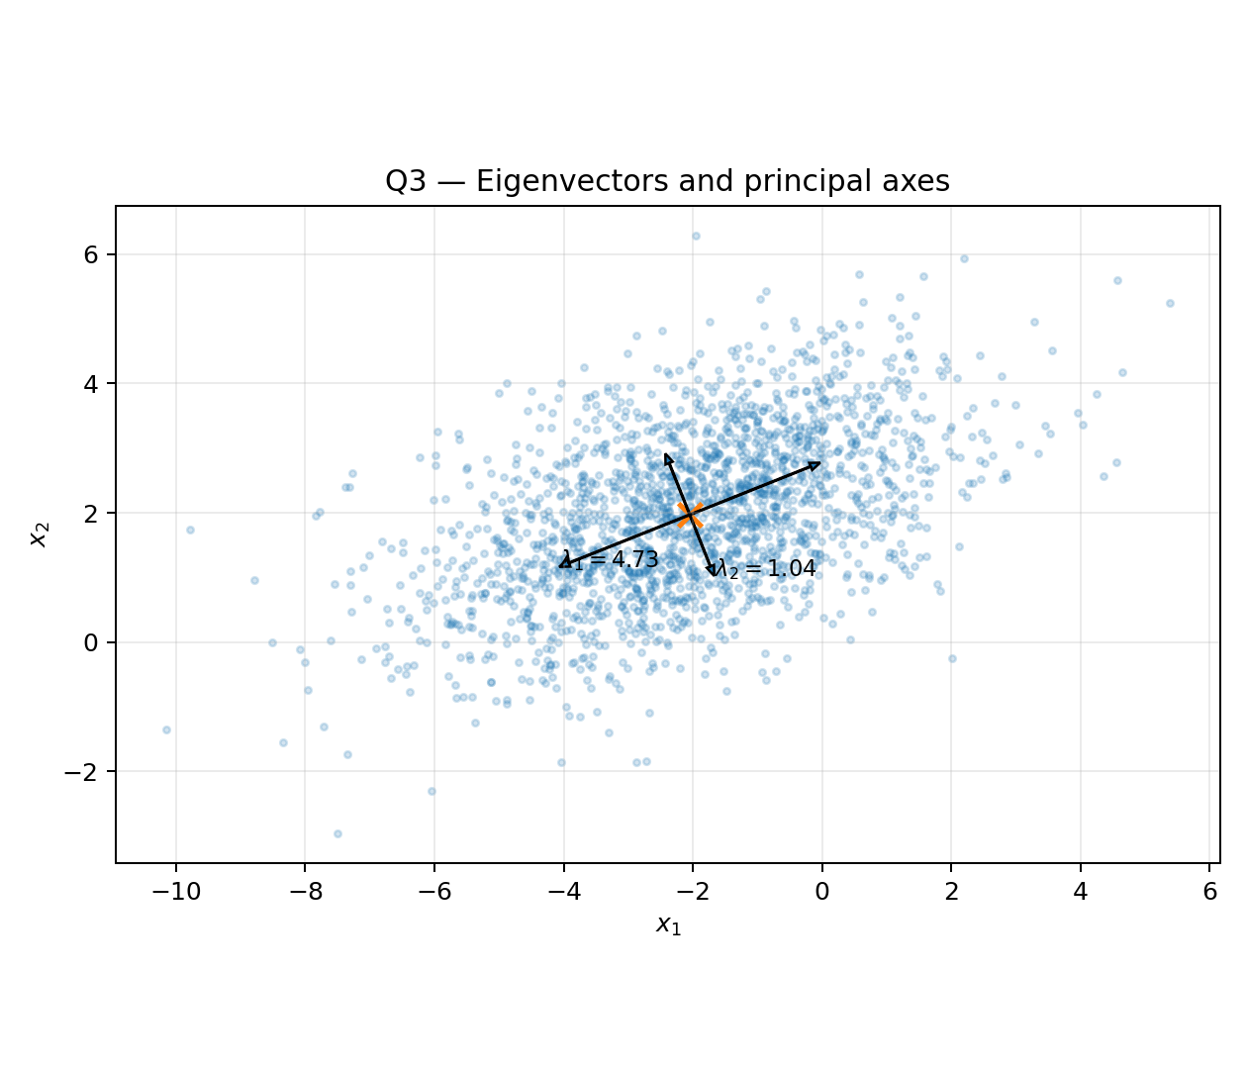
Estimated covariance = [[4.2245 1.2704]
[1.2704 1.5478]]. Eigenvalues = [4.7315 1.0408]. The first eigenvector points along the direction of maximum sample variance, while the second is orthogonal to it and represents the minimum-variance direction.

7. Q4 — Two Gaussian classes and decision boundaries
Class ω1 was generated with μ1=[−2,0]ᵀ and Σ1=[[1.2,0.3],[0.3,0.8]]. Class ω2 was generated with μ2=[2,1]ᵀ and Σ2=[[1.5,−0.4],[−0.4,1.0]]. The zero contour of the log-likelihood ratio was plotted as the decision boundary.
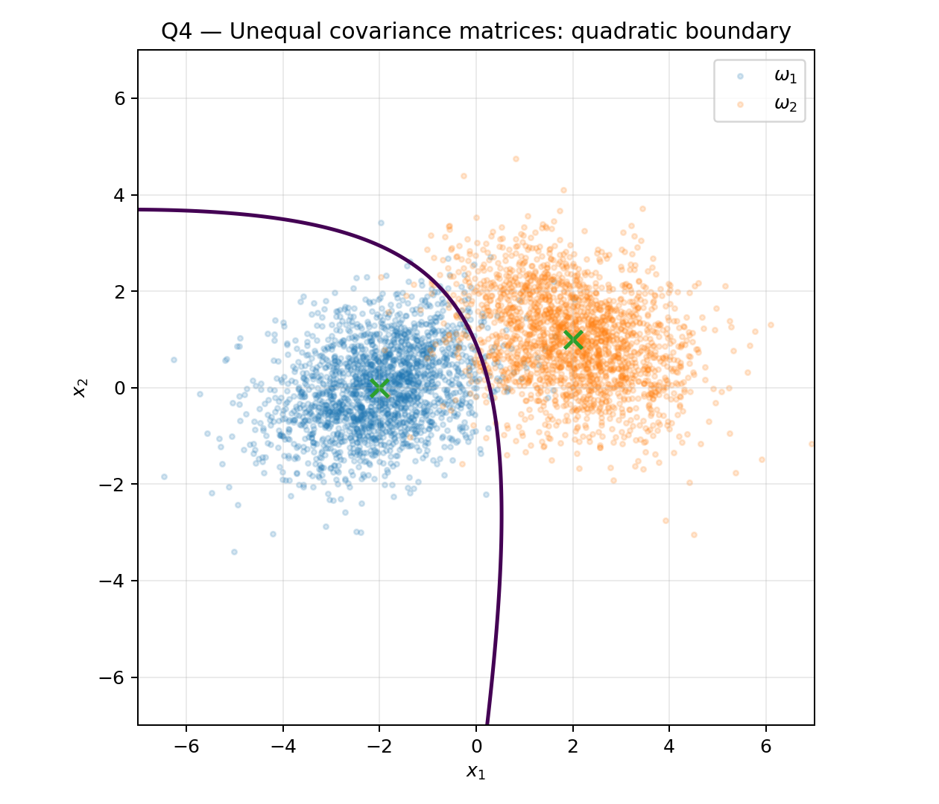
Because the covariance matrices differ, the quadratic terms do not cancel. The observed boundary is therefore generally curved rather than a straight line.
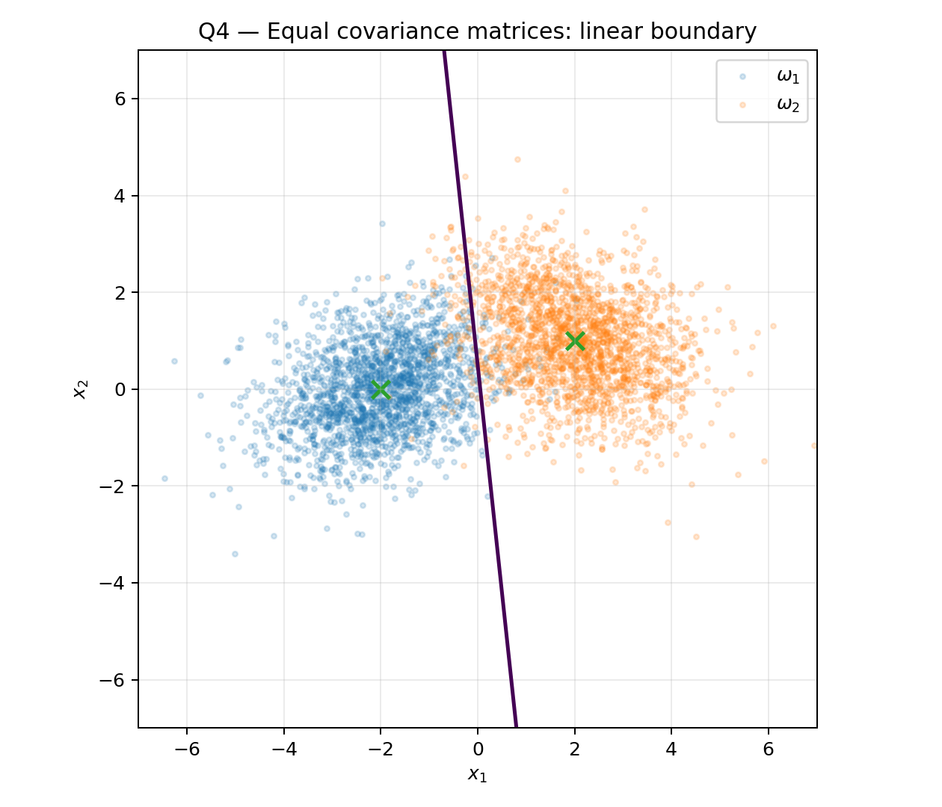
As a comparison, when both classes share the same covariance matrix, the quadratic terms cancel and the boundary becomes linear. This is the standard LDA/QDA distinction.
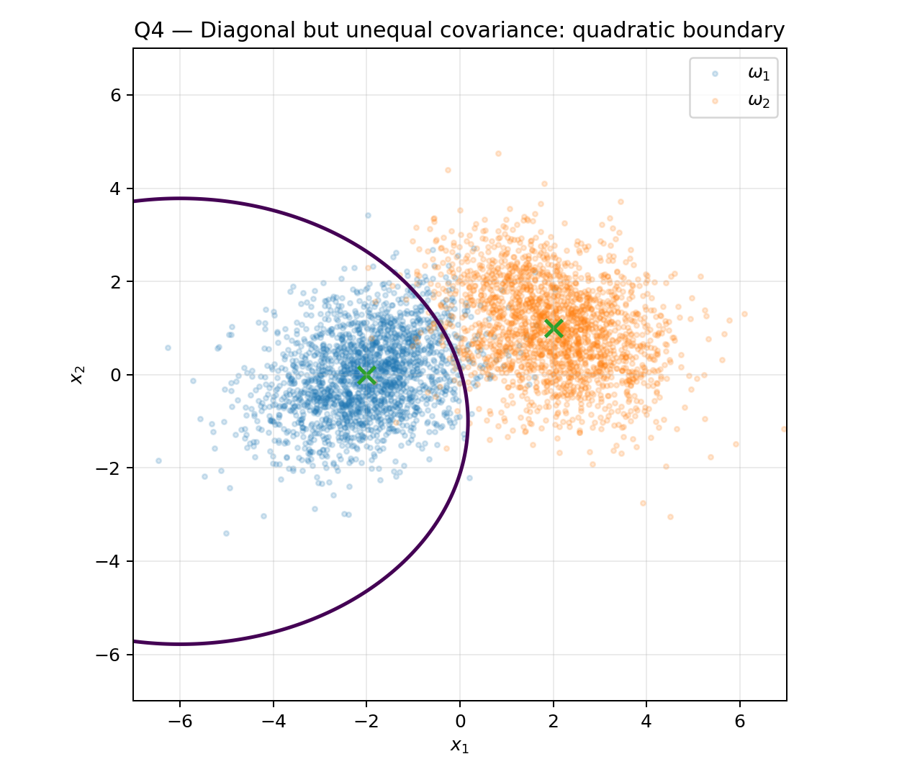
Even diagonal covariance matrices can produce a quadratic boundary if their diagonal entries differ between classes. The boundary need not be rotated, but it is not generally linear.

8. Conclusions
- An isotropic covariance matrix produces circular constant-density contours.
- A diagonal covariance matrix produces axis-aligned ellipses when the diagonal variances differ.
- A full covariance matrix with nonzero off-diagonal terms rotates the principal axes.
- Eigenvectors give the directions of the principal axes, while eigenvalues determine the squared spread along those directions.
- For Gaussian classification, equal covariance matrices lead to a linear discriminant boundary, whereas unequal covariance matrices generally lead to a quadratic boundary.
- The empirical covariance and eigenvalues approach their population values as the sample size increases.

